**HalloDoc Platform**

**AN INTERNSHIP REPORT**

***Submitted by***

**Goswami Dushyantpuri Lalitpuri**

**200200107023**

***In partial fulfillment for the award of the degree of***

**BACHELOR OF ENGINEERING**

***in***

**Computer Engineering Department**

**Government Engineering College Rajkot**



**Gujarat Technological University, Ahmedabad April, 2024**





**Government Engineering College, Rajkot Rajkot, Gujarat**

**CERTIFICATE**

This is to certify that the internship report submitted along with the project entitled **HalloDoc Application** has been carried out by **Goswami Dushyantpuri Lalitpuri** under my guidance in partial fulfillment for the degree of Bachelor of Engineering in Computer Engineering, 8th Semester of Gujarat Technological University, Ahmedabad during the academic year 2023-24.

Prof. Hardik Molia Prof. (Dr.) Sanjay Shah

Internal Guide Head of the Department

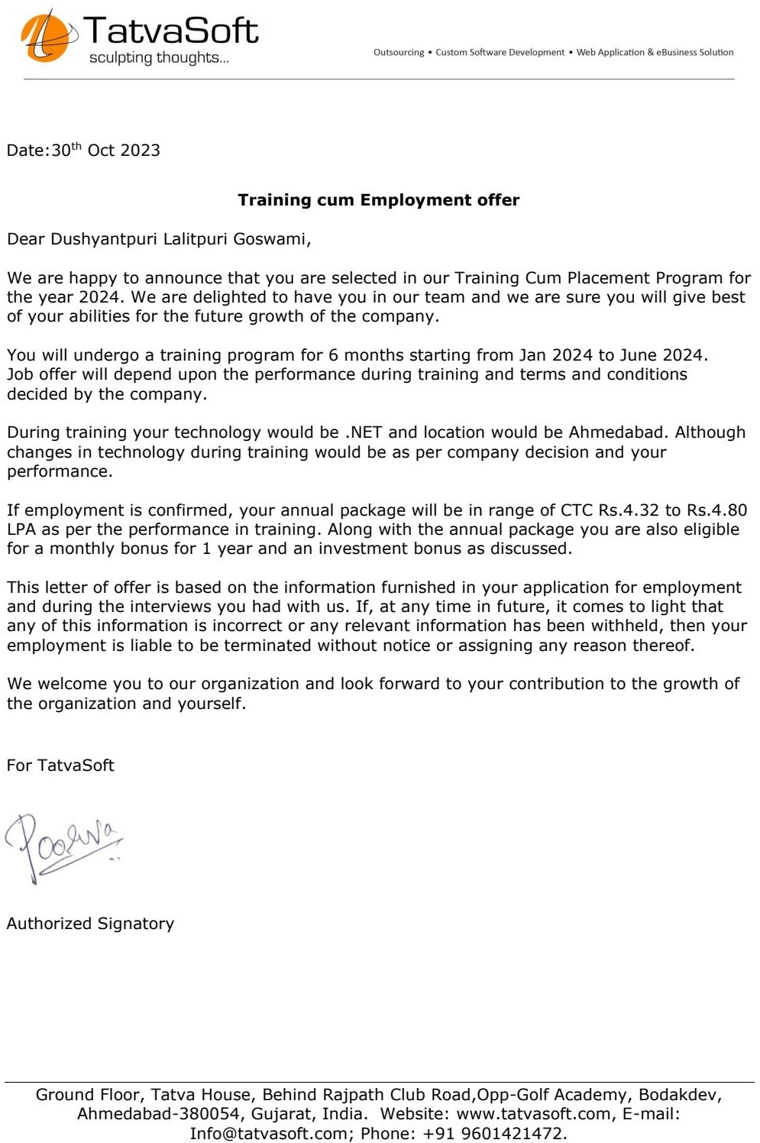





**Government Engineering College, Rajkot**

**Rajkot, Gujarat**

# DECLARATION

We hereby declare that the Internship report submitted along with the Internship entitled **HalloDoc Application** submitted in partial fulfillment for the degree of Bachelor of Engineering in Computer Engineering to Gujarat Technological University, Ahmedabad, is a bonafide record of original internship work carried out by me at TatvaSoft and that no part of this report has been directly copied from any students‟ reports or taken from any other source, without providing due reference.

|  |  |  |
| --- | --- | --- |
|  | Name of the Student | Sign of Student |
| 1. | Goswami Dushyantpuri Lalitpuri | |

# ACKNOWLEDGEMENT

I have taken many efforts in this internship. I faced lots of problems and tried my best to solve it. However, it would not have been possible without the kind support and help of many individuals and organizations. I would like to extend my sincere thanks to all of them. I am highly indebted to Asst. Prof. Hardik Molia for their guidance and constant supervision as well as for providing necessary information regarding the Internship Project Titled “HalloDoc Application”. I would like to express my gratitude towards our Head of the Department and other staff members of Computer Engineering Department. I even thank and appreciate to my colleague in developing the project and people who have willingly helped me out with their abilities.

Goswami Dushyantpuri

(200200107023)

# Abstract

*This internship was conducted at TatvaSoft as part of the curriculum at GTU (Gujarat Technological University). It provided an invaluable opportunity to apply theoretical knowledge in a practical setting, gaining real-world experience in software development methodologies and industry practices. The collaboration with experienced professionals at TatvaSoft enhanced skills in project management, teamwork, and problem-solving. Overall, this internship served as a cornerstone in bridging the gap between academic learning and professional application, paving the way for future career endeavors.*

*This internship report explores the development process of a software project, focusing on tasks such as understanding software requirements, designing user interfaces, integrating databases, implementing functionalities, and ensuring responsiveness. Through hands-on experience and learning sessions, valuable insights were gained into software development practices and tools. The report reflects on challenges faced, solutions devised, and lessons learned throughout the internship.*

**List of Figures**

Fig 2.1 Project Schedule 4

Fig 4.1 Use Case Diagram 9

Fig 4.2 Activity Diagram 10

Fig 4.3 Class Diagram 11

Fig 5.3.1 Dashboard of Admin Module 17

Fig 5.3.2 Admin Profile 18

Fig 5.3.3 Provider Location 19

Fig 5.3.4 Scheduling 19

Fig 5.3.5 Access Roles Page 20

Fig 5.3.6 Records Page 21

Fig 5.3.7 Dashboard Page for Patient 22

Fig 5.3.8 Patient Login Page 22

Fig 5.3.9 Patient Profile Page 23

Fig 5.3.10 Provider Dashboard 24

**List of Tables**

Table 5.1 Admin Table 13

Table 5.2 AspNetUser Table 13

Table 5.3 Physician Table 14

Table 5.4 User Table 14

Table 5.5 Request Table 15

Table 5.6 Order Details Table 15

Table 5.7 HealthProfessionals Table 16

**Abbreviations**

**List of Abbreviations:**

* UI: User Interface
* MVC: Model-View-Controller
* SQL: Structured Query Language
* SRS: Software Requirements Specification
* JWT: JSON Web Token
* SMS: Short Message Service
* .NET: Network Enabled Technologies
* CRUD: Create, Read, Update, Delete

# Table of Contents

Declaration i

Acknowledgement ii

Abstract iii

List of Figures iv

List of Tables v

Abbreviations vi

Table of Contents vii

**Chapter 1 OVERVIEW OF THE COMPANY 1**

* 1. HISTORY 1
  2. SCOPE OF WORK 1
  3. TECHNOLOGIES 1
  4. VALUES 2

**Chapter 2 INTRODUCTION TO INTERNSHIP 3**

* 1. INTERNSHIP SUMMARY 3
  2. PURPOSE 3
  3. SCOPE 3
  4. OBJECTIVE 3
  5. INTERNSHIP SCHEDULING 4

**Chapter 3 TOOLS & TECHNOLOGIES 5**

* 1. ASP.Net Core Entity Framework 5
  2. Language-Integrated Query (LINQ) 5
  3. PostgreSQL 5
  4. FRONTEND TECHNOLOGY 6
  5. SQL 6
  6. VISUAL STUDIO 6

**Chapter 4 SYSTEM ANALYSIS 7**

* 1. STUDY OF CURRENT SYSTEM 7
  2. WEAKNESS OF CURRENT SYSTEM 7
  3. FEATURES OF NEW SYSTEM 7
  4. ACTIVITY OF NEW SYSTEM 8

**Chapter 5 SYSTEM DESIGN & IMPLEMENTATION 12**

5.1 ABSTRACT OF SYSTEM 13

5.2 DATABASE DESIGN 13

5.3 INTERFACE DESIGN 16

**Chapter 6 TESTING 25**

6.1 TESTING PLAN 25

6.2 TESTING STRATEGY 25

**Chapter 7 CONCLUSION AND DISCUSSION 26**

7.1 OVERALL ANALYSIS OF INTERNSHIP VIABILITIES 26

7.2 PROBLEMS ENCOUNTERED AND POSSIBLE SOLUTIONS 27

7.3 DATES OF CONTINUOUS EVALUATION (CE-I AND CE-II) 27

7.4 SUMMARY OF PROJECT WORK 27

7.5 LIMITATION AND FUTURE ENHANCEMENT 27

**References 28**

# CHAPTER 1: OVERVIEW OF THE COMPANY

## HISTORY

TatvaSoft is a Consummate Custom Software Development company delivering splendid business IT Solutions and related services to customers across the globe. Our development services are led by our dedicated and passionate team to provide best industry practices combined with technology expertise and business domain knowledge to drive digital transformation. Our proficiency in understanding business challenges and professional competence allows us to create a better experience for our customers.

TatvaSoft has emerged and marked our presence in different continents by providing Be spoke software development services to all major Industry Domains.

## SCOPE OF WORK

* Asp.Net MVC, Asp.Net Core, NodeJS - Backend Technologies
* Android / IOS - Mobile Application
* Angular, Typescript, ReactJS - Frontend Technologies
* MSSQL, PostgreSQL, MongoDb - Database

## TECHNOLOGIES

* **Backend department**: Java, NodeJs, PHP, ROR, .Net
* **Frontend department**: Angular, React, Vue.js
* **Database department**: Microsoft SQL Server, PostgreSQL, Elasticsearch,MySQL, mongo DB, Cassandra, Oracle
* **Clouds & DevOps department**: AWS, Google Cloud, Docker, Jenkins, Kubernetes, Azure
* **Mobile department**: IOS, Android, React Native, Flutter, Xamarin.

## VALUES

* Data Driven
* Innovation
* Well established process
* Ethics & Integrity
* Agility
* Collaboration

# Chapter 2 INTRODUCTION TO INTERNSHIP

## INTERNSHIP SUMMARY

GTU provides the opportunity to get experience before students step into professional life. In January 2024, I began my internship at Tatvasoft Pvt. Ltd. Working at the office, I found inspiration in my everyday journeys thanks to a fantastic work environment. It was an opportunity for me to demonstrate my worth as an employee, a trustworthy colleague, and a dedicated student. I have worked across several tools during my course of internship. The encouragement and honest responses I received were more than enough to put me at ease. I am grateful to my mentor for giving me the opportunity to grow both physically and personally.

## PURPOSE

Excelling in exams and earning a degree alone may not be enough to succeed in today’s job market. Real world experience through internships is crucial for professional growth, expanding knowledge, and determining the right career path.

## SCOPE

Internships offer valuable opportunities to gain real-world experience, expand knowledge and determine career direction in today’s job market. They bridge the gap between academic learning and workplace skills, providing essential professional development for success in the modern employment landscape.

## OBJECTIVE

The main objective of this internship was to make candidates work-ready in web development using ASP .Net core technology. I was mainly focused on practical and self- learning. I aimed to build my programming base and write code by following coding standards. From an individual employee’s

point of view, the main aims are:

* + - Be self-assured and introduce ourselves in professional settings.
    - Be skillful in one or more areas of expertise.
    - Develop soft skills like taking public speaking initiatives, taking responsibility for some work/task/event and many more.
    - To gain leadership quality.

## INTERNSHIP SCHEDULING

## In managing any project, the whole plan of the project is made before its actual implementation. The plan of the project helps the team to work as per the schedule and helps to successfully complete the project. To plan a project the main requirements that are calculated are cost, duration, effort, scheduling, manpower, resource allocation, risk management etc. The plan of our project is as follows:

## Fig 2.1 Project Schedule

# Chapter 3 TOOLS & TECHNOLOGIES

**3.1 ASP.Net Core Entity Framework**

Entity framework is an Object Relational Mapping (ORM) framework .NET application supported by Microsoft. that offers an automated mechanism to developers for storing and accessing the data in the database.

The Entity Framework enables developers to work with data in the form of domain-specific objects and properties, such as customers and customer addresses, without having to concern themselves with the underlying database tables and columns where this data is stored.

* 1. **Language-Integrated Query (LINQ)**

Language-Integrated Query (LINQ) is the name for a set of technologies based on the integration of query capabilities directly into the C# language. Traditionally, queries against data are expressed as simple strings without type checking at compile time or IntelliSense support. Furthermore, you have to learn a different query language for each type of data source: SQL databases, XML documents, various Web services, and so on. With LINQ, a query is a first-class language construct, just like classes, methods, and events.

* 1. **PostgreSQL**

PostgreSQL is an object-relational database management system (ORDMBS), which means that it has relational capabilities and an object-oriented design. Using object-oriented features of PostgreSQL, programmers can: Communicate with the database servers using objects in their code. Define complex custom data types.

* 1. **FRONTEND TECHNOLOGY**

HTML is used to create the structure and content of web pages. It provides a set of markup tags that define the different elements on a webpage, such as headings, paragraphs, images and links.

CSS (Cascading Style Sheet) is used to style and layout webpages, allowing developers to control the visual appearance of HTML elements. It provides a set of rules for defining color, size, position, and other visual properties of HTML elements.

JavaScript is a scripting language used to create interactive and dynamic web pages. It allows developers to add behaviors and interactivity to web pages, such as responding to user input, manipulating HTML elements, and update content without refreshing the page.

* 1. **SQL**

SQL (Structured query language) databases are relational databases that use SQL as their primary programming language for managing and manipulating data. They organize data into tables, which are related to each other through common fields or keys. SQL databases are used to store and manage large amounts of structured data. They provide tools for creating, updating, and querying data, allowing developers to quickly retrieve specific information from a large database.

* 1. **VISUAL STUDIO**

Visual Studio is an Integrated Development Environment developed by Microsoft to develop GUI, console, web applications, mobile apps etc. With the help of this IDE, you can create manage code as well as native code. It is not a language specific IDE as you can use this to write code in python, HTML, CSS & many more.

# Chapter 4 SYSTEM ANALYSIS

## 4.1 STUDY OF CURRENT SYSTEM

* First thing is that the Analysis model is the study of Existing Systems, which is available. Without study of existing system analysis models cannot proceed.
* Here I create Database to manage the request, patient and user. All Admin must have logged in to access the system.
* Admin can manage roles, patient request, provider shifts and rules for the whole system.
* Patient can see their whole medical history in dashboard also create new request for him/her or someone else.

## WEAKNESS OF CURRENT SYSTEM

* Editing and maintenance of data is tedious as well as costlier
* If both service provider accept the service request at a time
* Lack of integration
* To operate manual system requires technical expertise on process detail

## FEATURES OF NEW SYSTEM

The features that are available in the Website.

* Admin Panel Management
* Provider panel management
* Patient panel management
* The whole system works with 3 different modules: admin, provider and patient, in the patient module I have to implement filters and have to display their created request with time and status and also patient can request again with dashboard. Which is not available in the previous system.
* In this browser send request to the controller, controller send the request to the model & model send the data through PostgreSQL database and frontend can manage display data.

## ACTIVITY OF NEW SYSTEM

### **Use Case**

## In software and systems engineering, a use case is a list of steps, typically defining interactions between actor and a system, to achieve a goal.

## The actor can be a human, an external system, or time.

## In systems engineering, use cases are used at a higher level than within software engineering, often representing missions or stakeholder goals.

## The detailed requirements may then be captured in Systems Modeling Language or as contractual statements.

## As an important requirement technique, use cases have been widely used in modern software engineering over the last two decades.

## Use case driven development is a key characteristic of process models

## and frameworks.

## With its iterative and evolutionary nature, use case is also a good fit for agile development.

## Fig 4.1 Use Case Diagram

### **Activity Diagram**

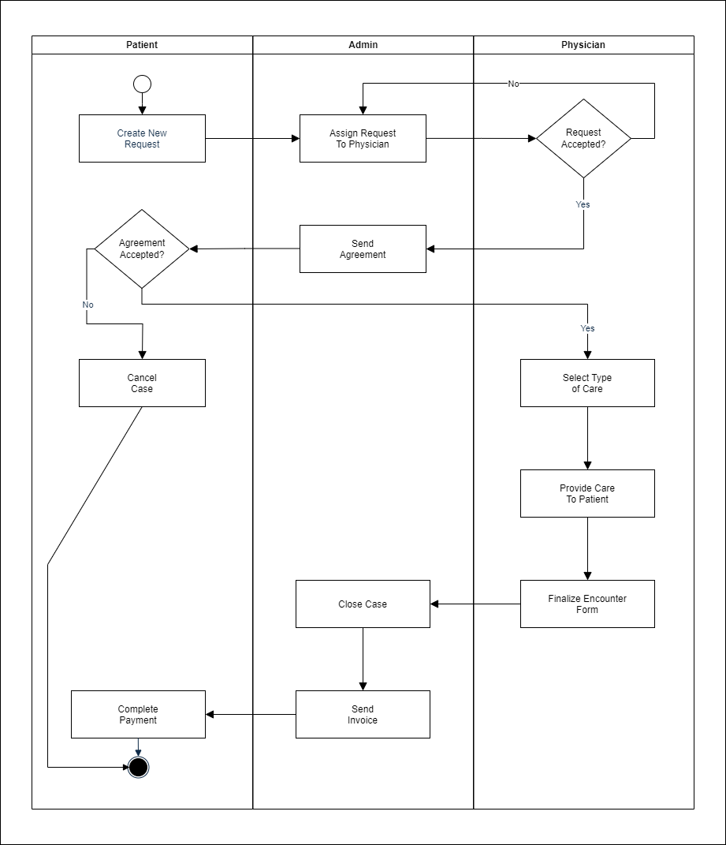Fig 4.2 Activity Diagram

### **Class Diagram**

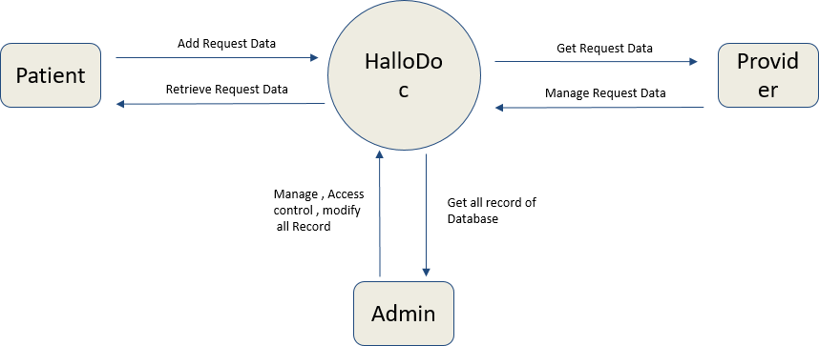

Fig 4.3 Class Diagram

# Chapter 5 SYSTEM DESIGN & IMPLEMENTATION

## 5.1 ABSTRACT OF SYSTEM

* **Server**

Operating System: Windows Processor:

Pentium 3.0 GHz or higher RAM: 2 GB or more

Hard Drive: 40 GB or more

* **Development Tools: Visual Studio, PostgreSQL database**

Communication between database and application system needs the internet connection into the system. Because all the data will be available in the server database. Using the web services fetch the data from the server

* **Admin**

1. Authentication – login with id and password

2. Accept Request, Block Request, Cancel Request

3. Schedule provider’s shift

4. Edit Their profile

5. Add New Roles

* **Customers**

1. Authentication – login with id and password

2. Add request for themselves

3. Add request for family/friend

4. View previous all requests and status of request

5. Edit their profile

## DATABASE DESIGN

## Database design is the process of producing a detailed data model of a database. This logical data model contains all the needed logical and physical design choices and physical storage parameters needed to generate a design in a Data Definition Language, which can then be used to create a database. A fully attributed data model contains detailed attributes for each entity.

## HalloDoc DATABASE MAIN TABLES

## 

Table 5.1 Admin Table

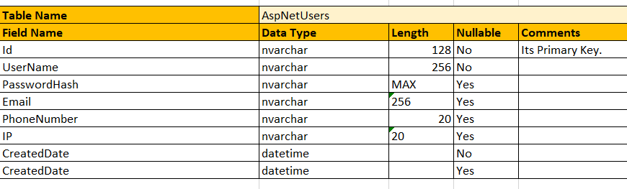Table 5.2 AspNetUser Table

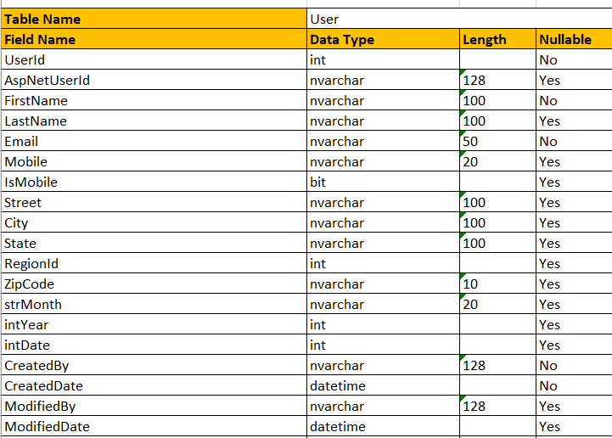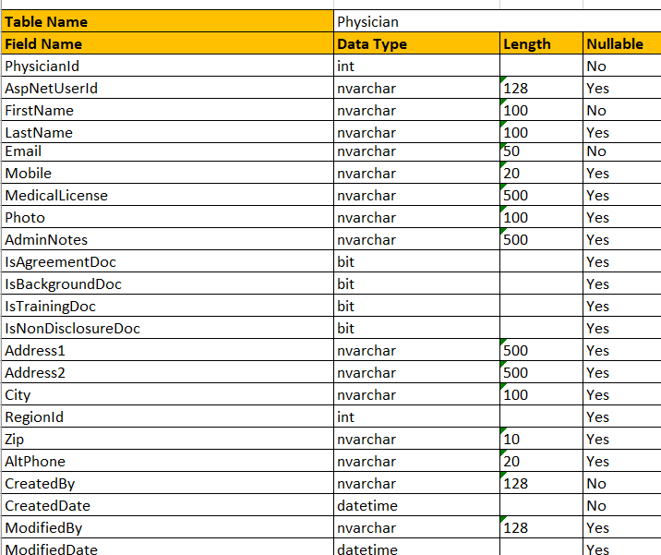Table 5.3 Physician Table

## Table 5.4 User Table

## 

## Table 5.5 Request Table

## 

## Table 5.6 Order Details Table

## Table 5.7 HealthProfessionals Table

## INTERFACE DESIGN

## It is a multi-vendor e-medical system consisting of admin, patient and provider modules. It manages patient request, provider shift, profiles and patient cases.

### **Admin Site**

* Admin can View and Delete patient’s appointments, their case history and view documents.
* Admin can send agreement to the patient.
* Admin can assign physician to the patient according to their area.
* Admin can send order for any requirement like medicines, oximeter or any medical thing etc.
* Admin can create physician account also.
* Admin can assign roles to the patient and physician and according to that they have access of limited area.
* Admin can create shift for provider on basis of which physician is available at that time.
* Admin can also block the patient & export patient’s records and do analysis on it.
* Admin can send the registration link to any new patient.

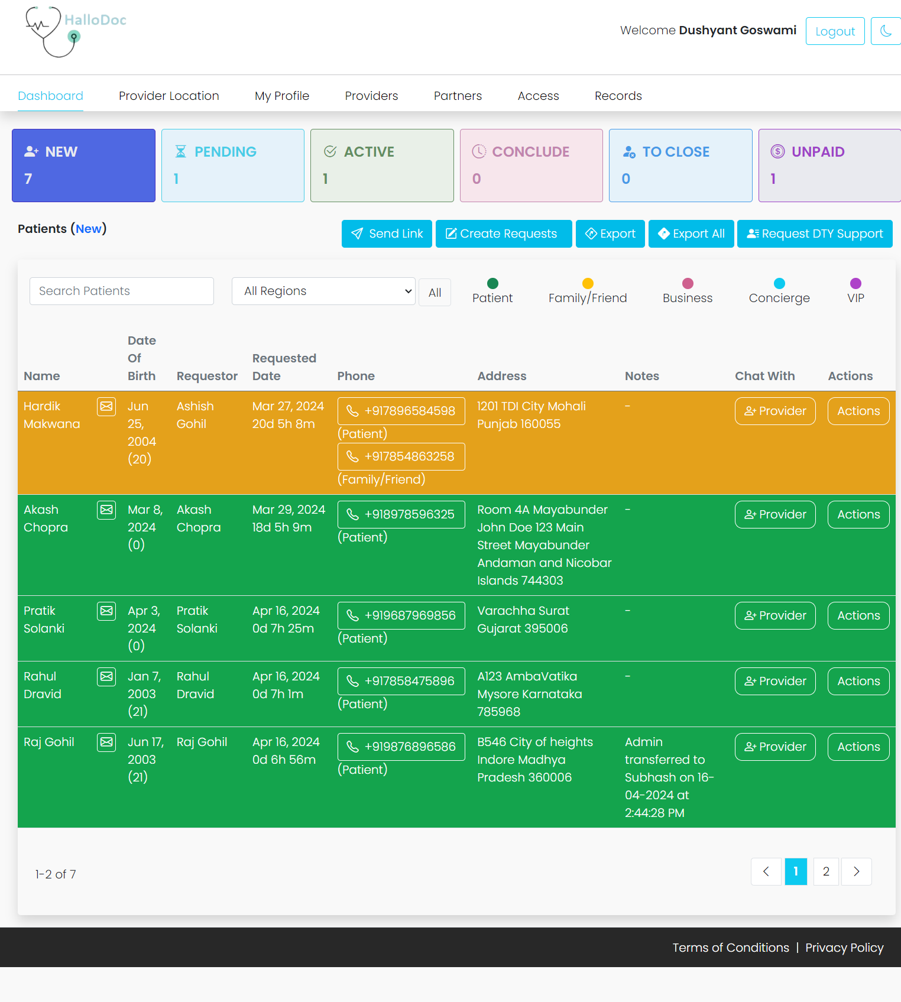

Fig 5.3.1 Dashboard of Admin Module

In admin dashboard provides a centralized interface for the admin to manage and oversee incoming requests. It offers quick access to different categories of requests based on their status, allowing the admin to efficiently review, approve, and take action as needed.

Fig 5.3.2 Admin Profile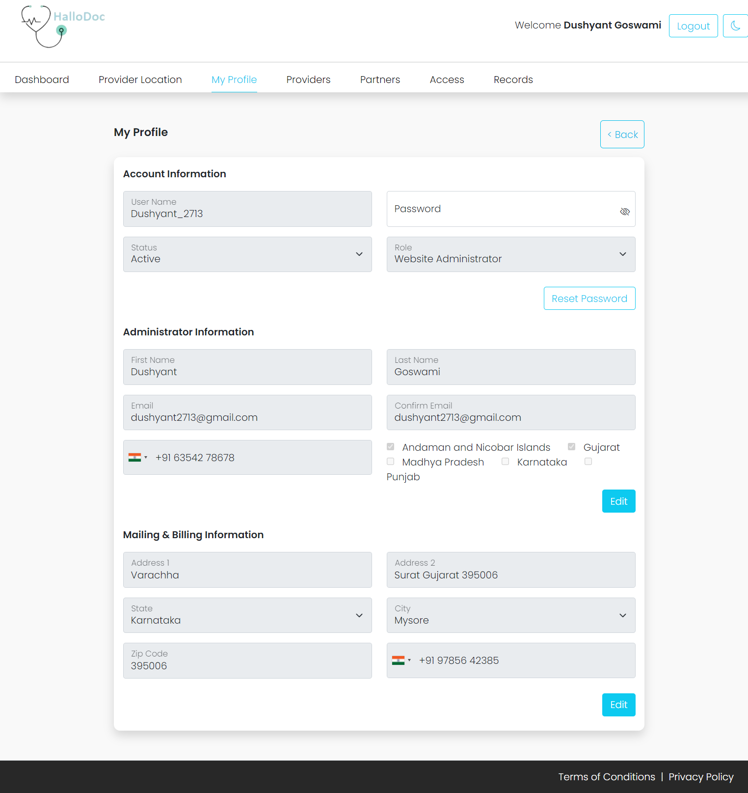

This is admin profile, all details of admin include in this page, Admin can also edit his/her details whenever he/she wants.

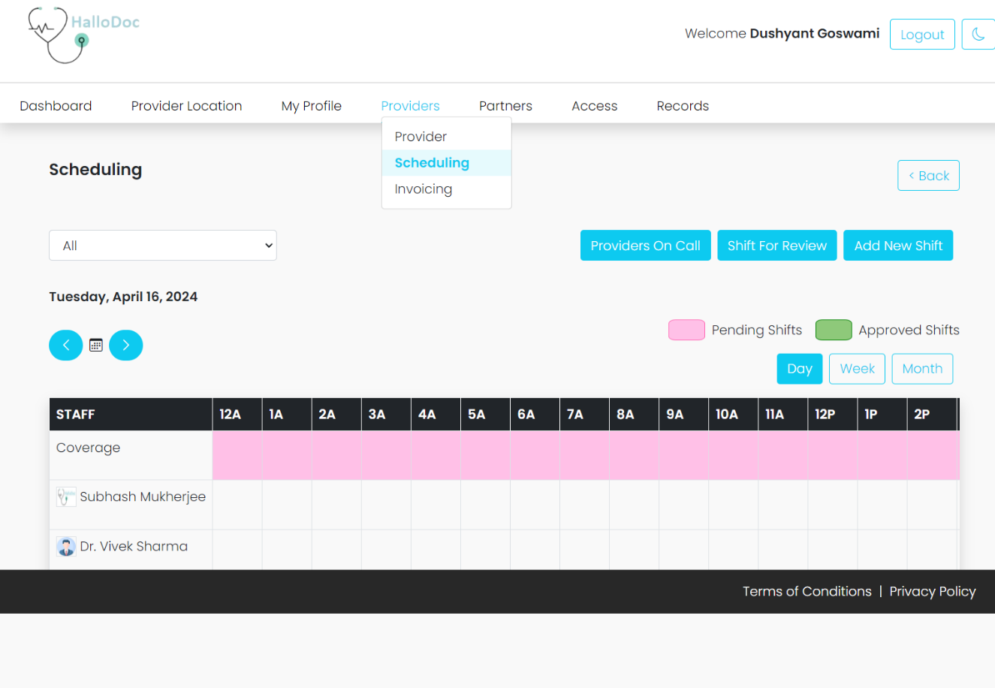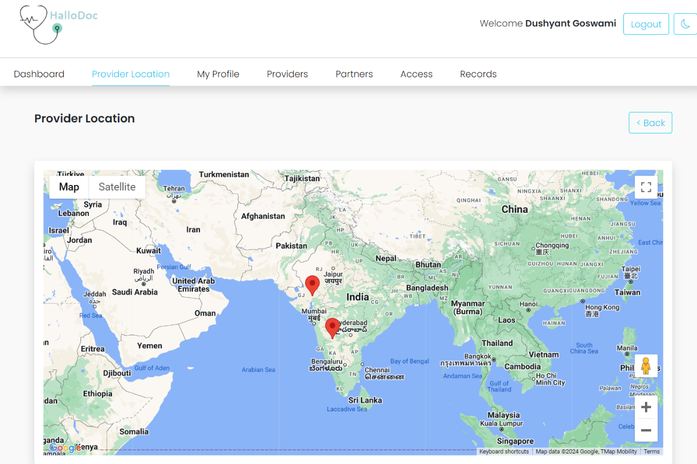Fig 5.3.3 Provider Location

Fig 5.3.4 Scheduling

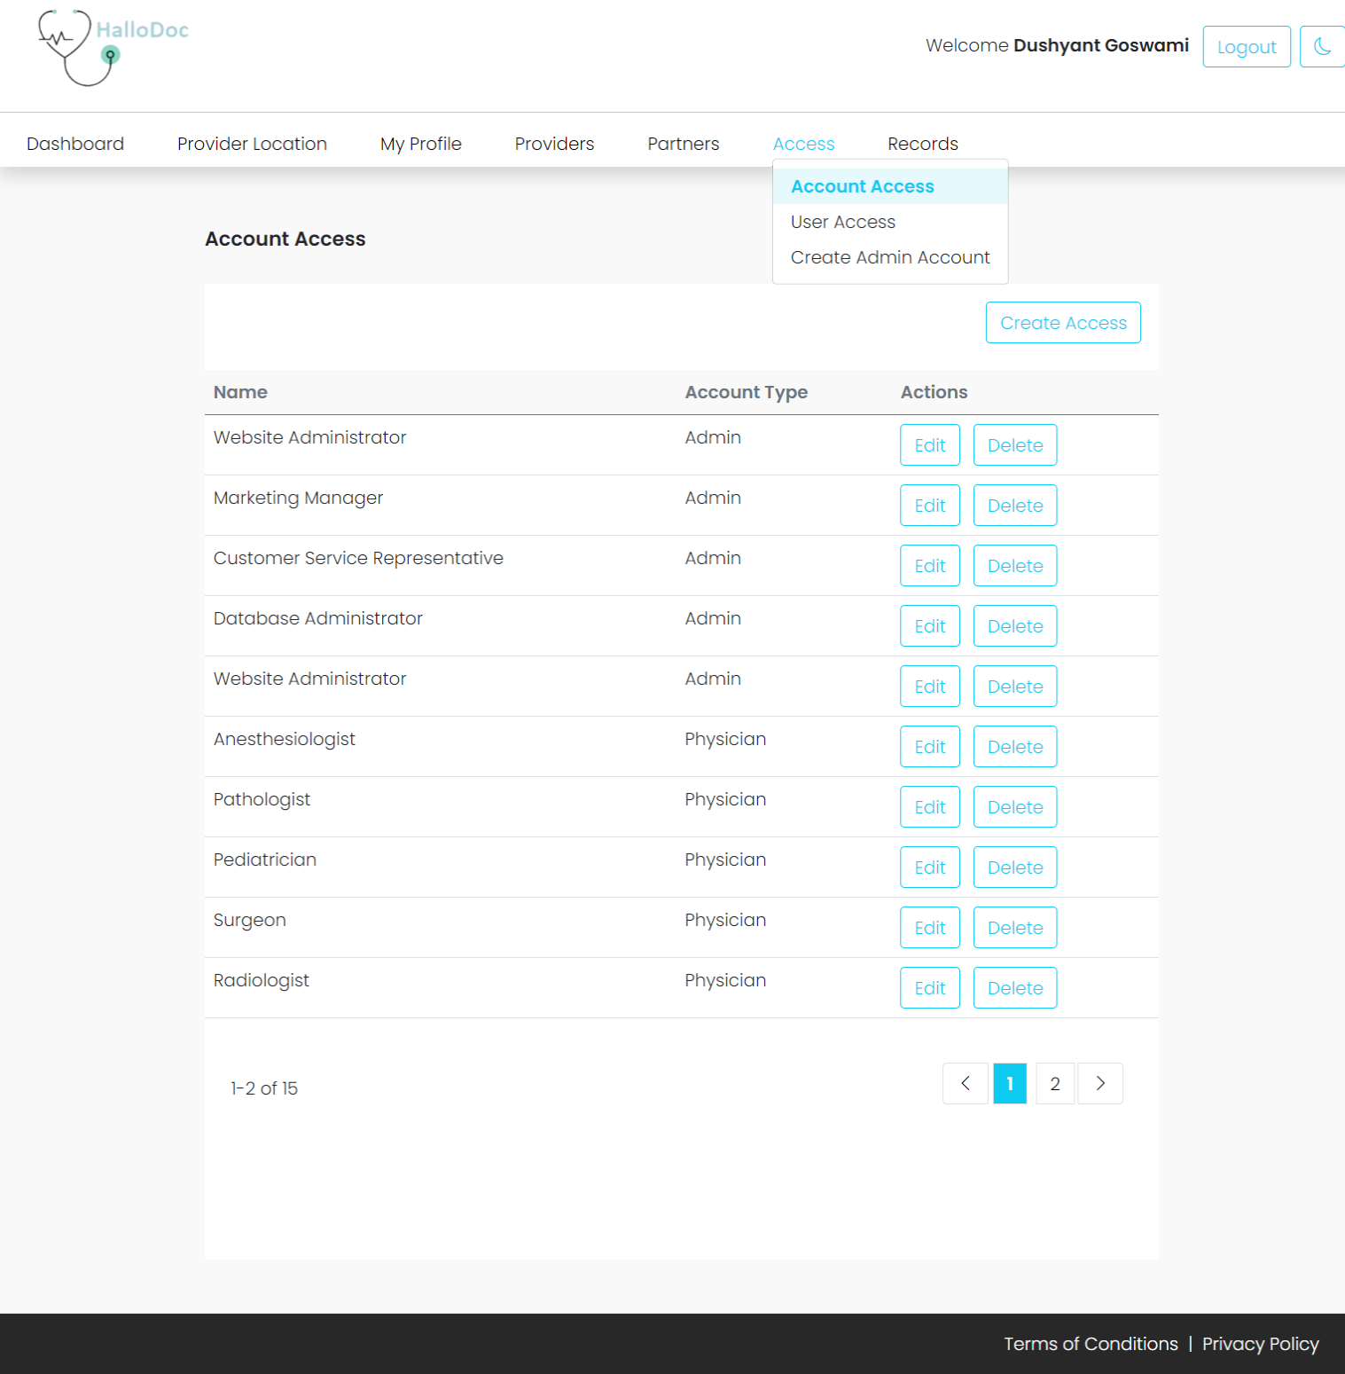Fig 5.3.5 Access Roles Page

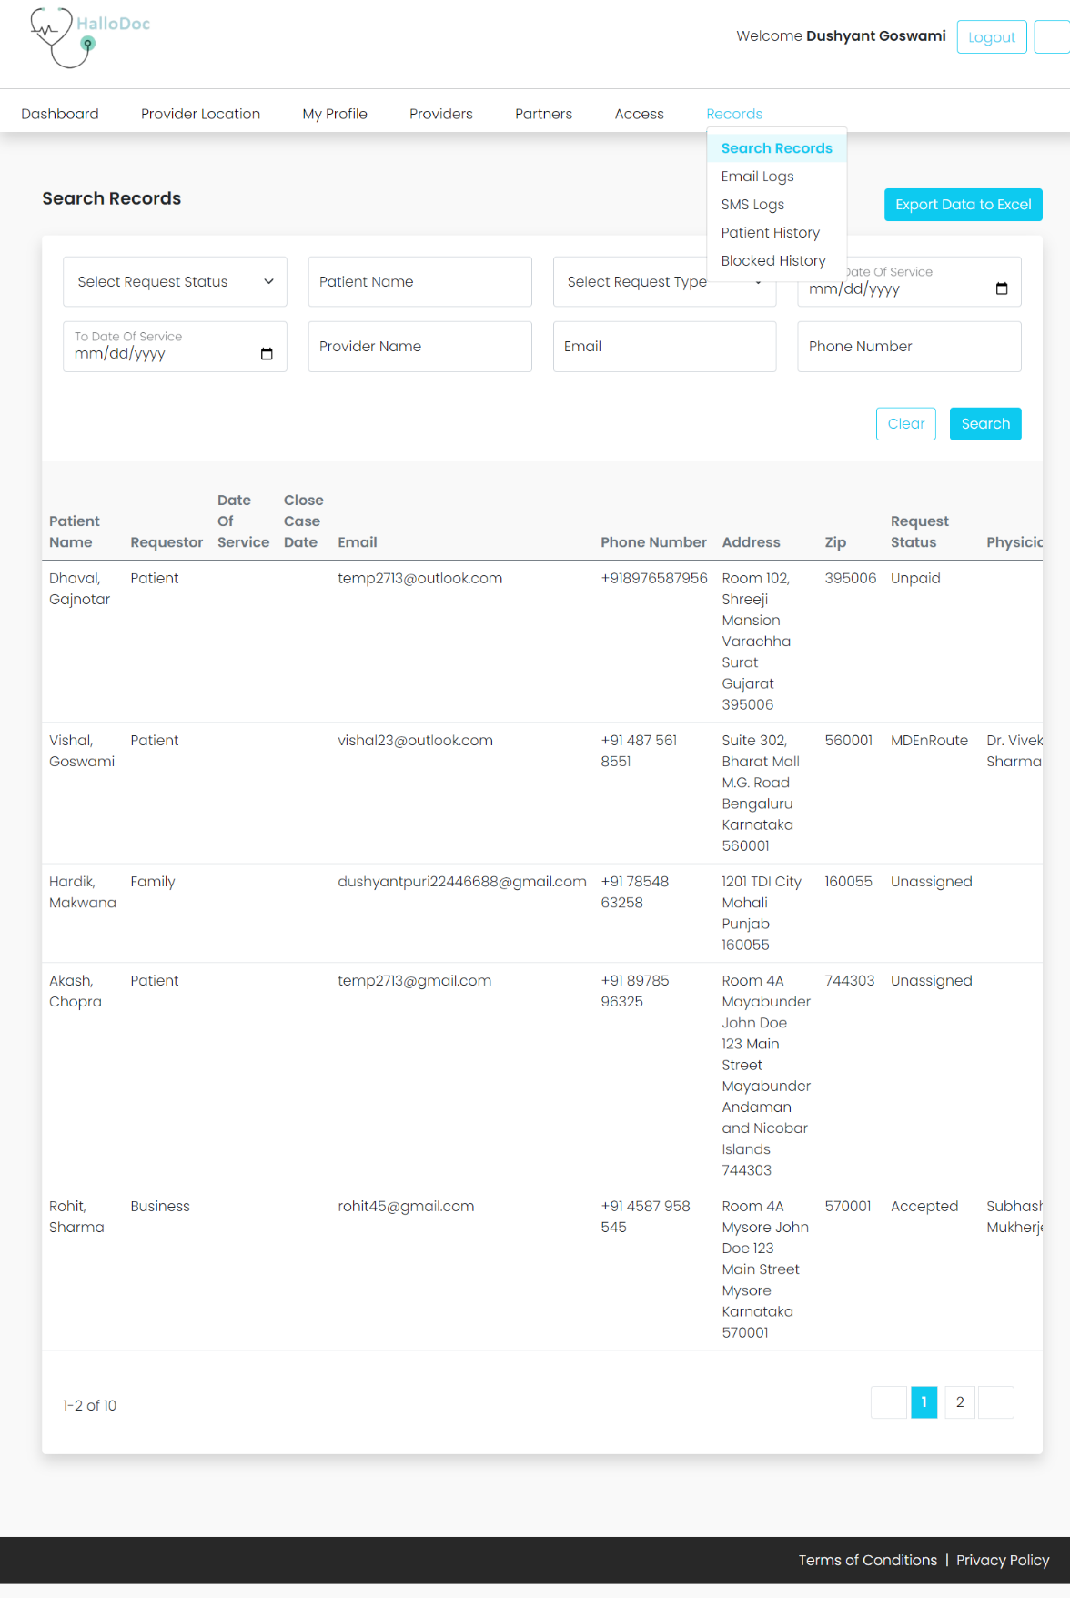

Fig 5.3.6 Records Page

## Patient Module

* Patient can create their account and book an appointment for their problem.
* Patient can view their history and documents.
* Patient can update their profile.
* 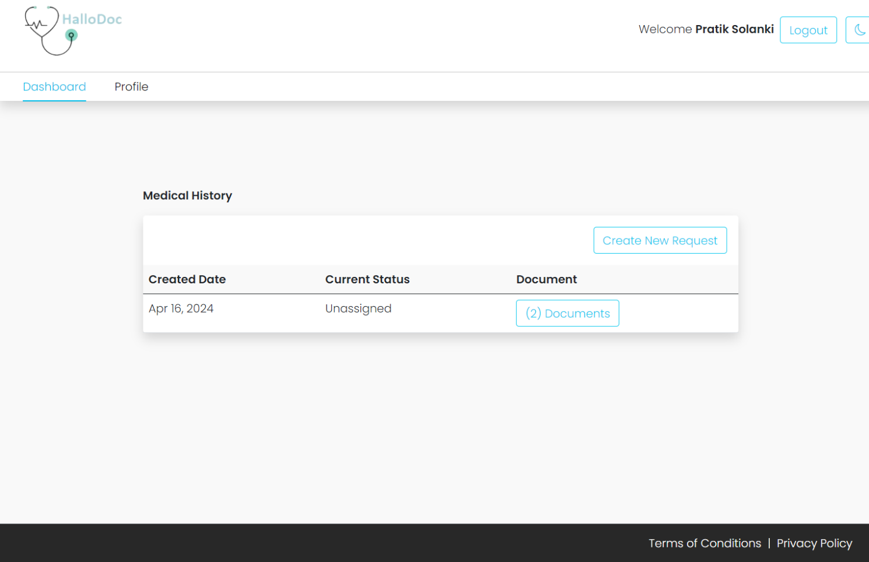Patient can accept or decline the agreement if he/she don’t want to continue.

## Fig 5.3.7 Dashboard Page for Patient

## Fig 5.3.8 Patient Login Page

## Fig 5.3.9 Patient Profile Page

## Provider Module

* Physician can login to their account and see if there are any shifts for the day or not.
* Physician can give Home Service also.
* If physician is not available, he/she can transfer the case back to the admin.

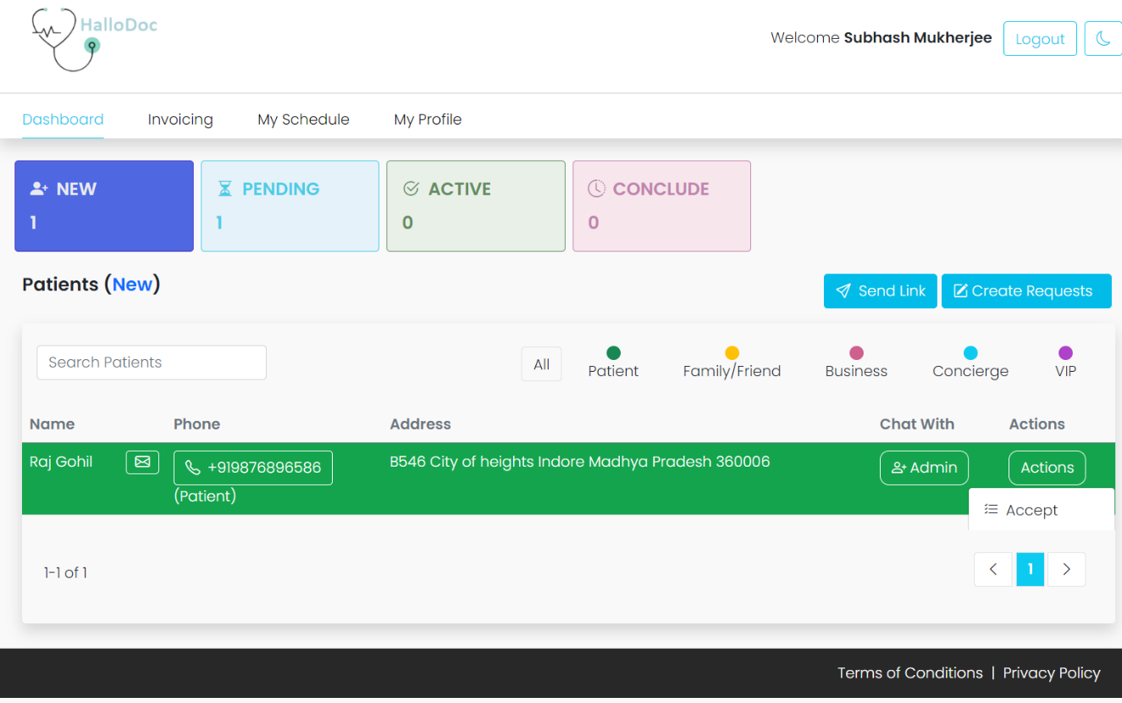

Fig 5.3.10 Provider Dashboard

# CHAPTER 6 TESTING

## TESTING PLAN

## The testing technique that is going to be used in the project is White box testing. In White box testing the Tester has knowledge about the internal structure of the code or the program of the software.

**White Box Testing:**

* It is a software testing process in which the internal structure, design and coding of the software is tested to ensure the flow of input-output and improve design, usability and security.
* Out of the 2 methods for testing, black box testing and white box testing, we would be using the white box testing as we are well aware of the internal functionalities of our application unlike in the black box testing.

## TESTING STRATEGY

## The development process repeats this testing subprocess a number of times for the following phases.

**Unit Testing:**

It ensures that all code meets quality standards before it's deployed. Also, it detects software bugs earlier.

**Integration Testing:**

It tests whether the various programs that make up a system, interface with each other as desired, fit together and whether the interfaces between the programs are correct.

# CHAPTER 7 CONCLUSION AND DISCUSSION

* 1. **OVERALL ANALYSIS OF INTERNSHIP VIABILITIES**
* According to me, this project is absolutely a good start for gaining hands-on experience on projects. It is useful if it is managed according to the goal for which it is made. It also saved 3- 4 hours of my time daily.
  1. **PROBLEMS ENCOUNTERED AND POSSIBLE SOLUTIONS**
* There are so many problems encountered during this project.
* Problem to working alone on a project, so I have to handle both the frontend and backend. Also, I am not familiar with .Net earlier btw through training and learning from seniors I overcame this problem.
* Need to change some functionality fully which leads me to do the whole work again. Some problems are solved easily with some changes.
  1. **DATES OF CONTINUOUS EVALUATION (CE-I AND CE-II)**
* CE-I (11/03/2024)
* CE-II (16/04/2024)
  1. **SUMMARY OF PROJECT WORK**
* Completing this project an incredible achievement. Prior knowledge of software engineering is very helpful in overcoming various hurdles. I have done work with pre- planned scheduling related to time constraints and weekly progress in project development. I have done work with pre-planned scheduling related to time constraints and weekly progress in project development.
* In general, a well-designed and effectively implemented HalloDoc Platform using .NET and SQL can help companies to meet their social responsibility goals, increase employee engagement and satisfaction, and build positive relationships with the broader community. By

addressing the limitations of the current system and incorporating future enhancements, the platform can continue to evolve and improve over time, ultimately resulting in greater social impact and value for both the company and the community.

* 1. **LIMITATION AND FUTURE ENHANCEMENT**
     1. **Limitation**
        + Resource Constraints: Implementing and managing a comprehensive healthcare platform like HalloDoc can pose significant challenges in terms of resources. This includes funding, staffing, and technological infrastructure. The company may encounter budget limitations, difficulty in recruiting and retaining specialized staff, and challenges in maintaining and upgrading the technological framework necessary for HalloDoc's operations.
        + Limited Community Engagement: HalloDoc may face obstacles in engaging with the broader community and establishing lasting relationships with healthcare organizations and professionals. This limitation could potentially curtail the platform's ability to have a widespread impact and maximize its effectiveness in addressing healthcare needs.
     2. **Future Enhancement**
* Digital Accessibility Challenges: Despite the advantages of a digital healthcare platform like HalloDoc, accessibility barriers may hinder its effectiveness for certain user groups. Individuals with disabilities or those lacking access to reliable internet connections or digital devices may face challenges in utilizing the platform's services. Addressing these accessibility issues requires additional resources and technological adaptations to ensure inclusivity and equal access to healthcare resources for all users. Failure to adequately address these challenges could limit HalloDoc's reach and impact, particularly among vulnerable populations with limited access to traditional healthcare services.
* Mobile and Remote Access: Offering seamless access to HalloDoc through mobile devices and remote workstations would significantly enhance user convenience and accessibility.

# REFERENCES

* <https://www.csharpcorner.com/>
* <https://stackoverflow.com/>
* <https://www.w3schools.com/>
* <https://www.geeksforgeeks.org/>
* <https://www.canva.com/>
* <https://www.lucidchart.com/>
* <https://dotnet.microsoft.com/en-us/learn/csharp>
* <https://learn.microsoft.com/en-us/dotnet/core/introduction>
* <https://getbootstrap.com/>
* <https://jquery.com/>
* <https://cdnjs.com/>